**REPUBLIC OF THE PHILIPHINES**

**BICOL UNIVERSITY POLANGUI CAMPUS**

**POLANGUI, ALBAY**

**IS 311 – IS EMERGING TECHNOLOGIES AND TRENDS**

TOLARBA, JOSHUA P.

BSIS / 3 / A

2ND SEMESTER 2020-2021

SUBMITTED TO:

MS. SHEENA LUZ S. REFRAN

Instructor 1

**Final Requirement**

1. In your own words, how does information system affect your daily life?

* IS helps in terms of management, sortation, removing unneeded items or files and even help us to make solution for every problem we encounter because IS also has a logic that we need to urgently solve.

1. Why do we need information systems?

* We need information system because nowadays we mostly use technology, social media and other related things. We need information system in terms of privacy, management and even in identification of information we read if it is a legit source of information.

1. How does information system help business?

* Simply IS helps the business to manage all their information, make a better decision, and also improve their business processes.

1. Why are information Systems important in business?

* Because every business have their own system in different sector, the purpose of the IS here is to manage all the incoming data that makes it easier for the businesses. It also makes easier to store operational data, communication records and documents.

1. Research and show a sample diagram of the following models and give an example of each model that was used or applied in an existing system.
2. Binary Tree Model

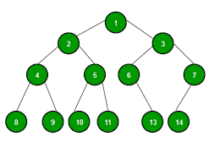**Sample**

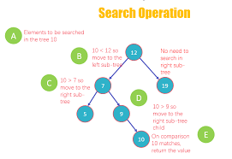**Existing System**

1. Hierarchy Model

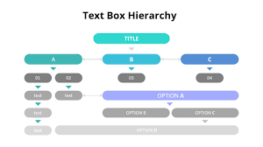**Sample**

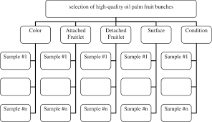**Existing System**

1. Hypertext Model

**Sample**

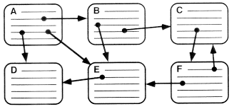

**Existing System**

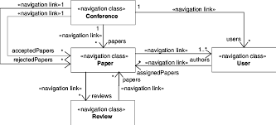

1. Random Access Mode

**Sample**

**Existing System**

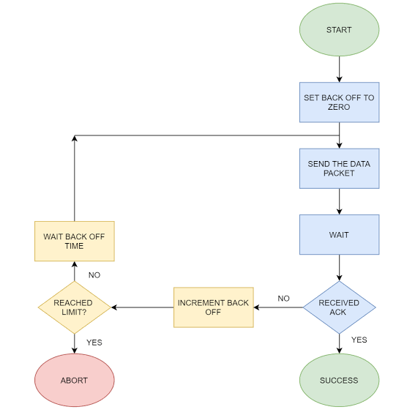

1. Identify some changes in the business environment with regards to the business and information technology sectors.

* The changes in business environment with regards with the business and IT sector are:
* There as impact in terms of the operating costs
* Security of the sensitive information
* There is also an improved in communication process
* It boost employee productivity
* Broaden Customer bases
* Collaboration and Outsourcing

1. Identify factors that makes business environment complex in nature.

* Geographical and Ecological or natural factors.
* Demographic Factors.
* Economic Factors.
* Political and legal factors
* Social and cultural factors.
* Physical and Technological factors

1. How does business environment affect companies in different industries?

* For me business owners and managers is having a great time in dealing of control over the internal environment of business, that covers the day-to-day decisions like choosing the supplies they purchase, which employees should they hire, the products that need to be sell, and where they sell those products. They use their skills and resources to create goods and services that will satisfy existing and prospective customers. However, the external environmental conditions that affect a business are generally beyond the control of management and change constantly. To compete successfully, business owners and managers must continuously study the environment and adapt their businesses accordingly.

1. An information system is essentially made up of what five components? And these components are integrated to perform what?

* Information system is essentially made up of five components which are the hardware, software, database, network and people. And this are integrated to five components: perform input, process, output, feedback and control.

1. What are the roles of the following systems?

* Operations support system
* The role of operations support system is that it enables provider to monitor, control, analyse, and manage the services on its network.
* Transaction Processing System (TPS)
* The main role of Transaction processing system is to collect, store, modify and retrieve the transaction of an organization
* Process Control System
* Its main role is to monitor and control the physical process of an organization.
* Enterprise Collaboration System
* The job of enterprise collaboration system is to ensure that the workers can work in different departments and at the same time can communicate, it also able to employees to perform tasks in minutes that used to take hours, and secures all the documents, job tasks and communication needs are in one safe place.
* Management Support System
* To provide external and internal information using various data analysis tools to manage for planning and decision making.

1. Differentiate Information systems and Information Technology and make a comparison table in terms of its origin, development and business application.

|  |  |  |
| --- | --- | --- |
|  | **Information System** | **Information Technology** |
| **Definition** | It is software that helps you store, manage, sort, organize, delete and analyse data. | It is the use of computers to store, retrieve, data or information. |
| **Origin** | Information systems have been in existence since pre-mechanical era in form of books, drawings, etc. | The origin of information technology is mostly associated with invention of computers. |
| **Development** | Information systems have undergone great deal of evolution, i.e. from manual record keeping to the current cloud storage system. | Similarly, information technology is seeing constant changes with evermore faster processor and constantly shrinking size of storage devices. |
| **Business Application** | Businesses have been using information systems for example in form of manual books of accounts to modern tally. The mode of communication has also gone under big change, for example, from a letter to email. | Information technology has helped drive efficiency across organization with improved productivity and precision manufacturing. |

1. Identify some impacts of the internet on business.

* The Internet has changed not only a business' customer base, but how a business communicates with its employees, and finds and manages the competition.
* Ability to Communicate.
* Rise of Telecommuting.
* Marketing to a Wider Area.
* Using Digital Advertising.
* Collaborating with Other Businesses.
* Using the Internet for Research

1. What does Emerging technology means?

* Emerging technology is a term generally used to describe a new technology, but it may also refer to the continuing development of an existing technology; it can have slightly different meaning when used in different areas, such as media, business, science, or education.

1. Which countries are the biggest users of the Internet? Social media? Mobile?

* INTERNET- China
* SOCIAL MEDIA- China
* MOBILE- China

1. Which country had the largest Internet growth (in %) in the last five years?

* China

1. How will most people connect to the Internet in the future?

* • They predict mobile, wearable, and embedded computing will be tied together in the Internet of Things, allowing people and their surroundings to tap into artificial intelligence-enhanced cloud-based information storage and sharing.

1. What are two different applications of wearable technologies?

* Virtual reality and Augmented Reality are an example of wearable technology.

1. What are two different applications of collaborative technologies?

* Internet forums which serve as discussion platform on the the internet that facilitates and manage online message, and online chat which also facilitate manage real-time messages.

1. What capabilities do printable technologies have?

* Printable technologies have the capability to print 3-D prototypes for testing on the market; it can also be used to create various other things such as prosthetic and guns.

1. How will advances in wireless technologies and sensors make objects “findable”?

* When data from a large number of sensors is combined with powerful display or visualization technology, decision makers can gain a better understanding of real-time occurrences.

1. What is Nanobot?

* It is miniature robots that are approximately one to 100 nanometres in scale that is usually used in medical purposes.

1. What is a UAV?

* An unmanned aerial vehicle, sometimes known as a drone, is an aircraft that does not have a human pilot, crew, or passengers on board.

1. If you were going to start a new technology business, which of the emerging trends do you think would be the biggest opportunity?

* If I were going to start a new technology business I think I’ll go with the mobile application because if we will consider the situation we are in today most of us rely on the mobile apps, so by improving more your business the possibility of you in becoming a successful business man is very easy what you just need is proper management.